**MEMBERS:**

Renato Illescas R

Gustavo Londa

Ronny Moran

**ARTIFICIAL INTELLIGENCE**

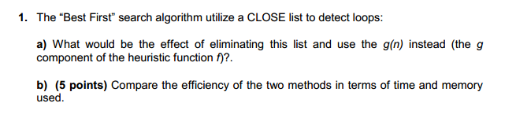

1. In fact we lose the search history of the route to the final solution, the closed list saves the iterations on the past of each visited node, which closed list shows the objective obtained through the shortest route, thus the algorithm allows return to a node and path of the final solution, instead the function g(n) indicates the heuristic value of source to the destination within the search algorithm and not the global information with which the algorithm could return the search for a better route
2. Using g(n) could be more efficient. This doesn’t save queue information, and so does the time spent in the search, so the time and memory used is reduced.

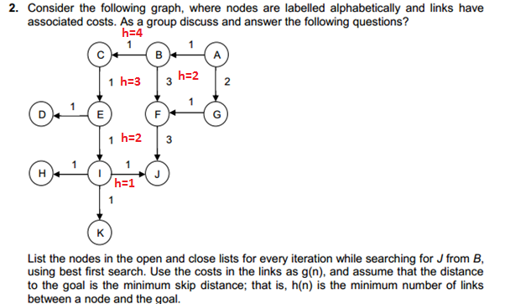

|  |  |  |
| --- | --- | --- |
| Open List | Closed List | X (node) |
| B-3 | - | - |
| C-4 F-4 | B-3 | B-3 |
| E-3 F-4 | B-3 C-4 | C-4 |
| D-1 I-2 F-4 | B-3 C-4 E-3 | E-3 |
| I-2 F-4 | B-3 C-4 E-3 D-1 | D-1 |
| H-1 K-1 J-1 F-4 | B-3 C-4 E-3 D-1 I-2 | I-2 |
| K-1 J-1 F-4 | B-3 C-4 E-3 D-1 I-2 H-1 | H-1 |
| J-1 F-4 | B-3 C-4 E-3 D-1 I-2 H-1 K-1 | K-1 |
|  |  | J-1 |